Lab - Determine the Encryption Algorithm to Use
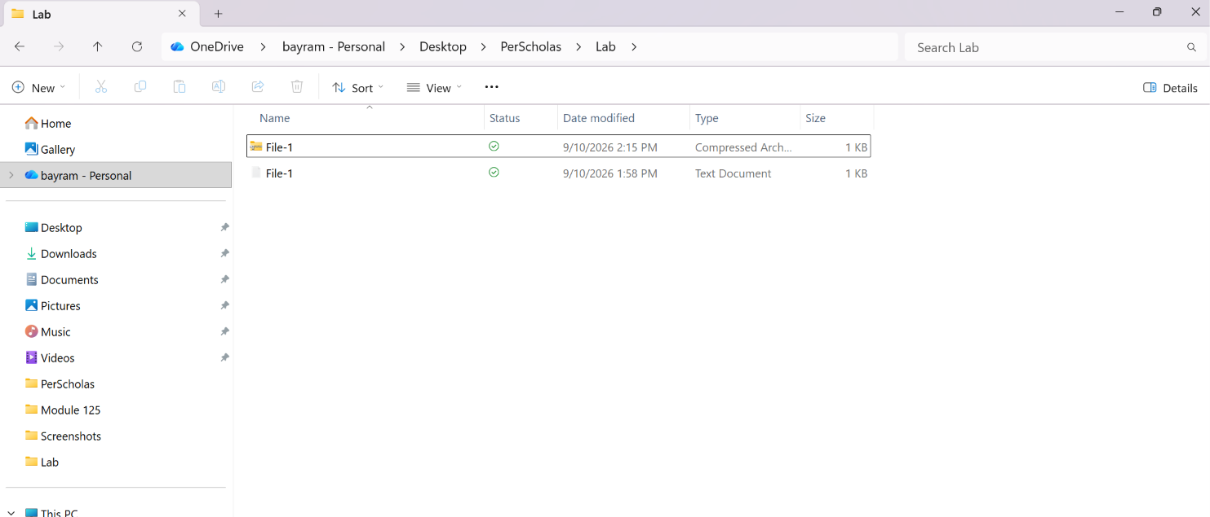

Objectives
Part 1: Secure Personal Data
Part 2: Secure Wireless Data
Part 3: Secure Corporate Data Between Sites

Background / Scenario
The internet is used for a variety of reasons including work, play, entertainment, and more. There are multiple protocols, algorithms, and methods available to secure online access.
This lab includes three scenarios. In each scenario, you will complete some steps and then do some internet research to answer questions, including what is the best encryption algorithm for each scenario.

Required Resources
= A Windows PC with internet access

Instructions

Part 1: Secure Personal Data
In this scenario, you are a student using a shared computer. You would like to save some confidential information on this computer but you do not want others to access that data.

Step 1: Create a text file.
a. Open File Explorer by searching for it or by using the Windows Key + E keyboard combination.
b. Navigate to a working location and create a new folder with a name of your choice.
Note: To show file extensions, click View > Options. In the Folder Options window, click the View tab, and then uncheck Hide extensions for known file types.
c. Inside the folder, right click in the empty space and click New > Text Document.
d. Change the name to File-1.txt, and then double-click it to open the file.
e. Enter some text, such as "This is a test.", and then save and close the file.

Step 2: Discuss how could you protect this file.
Assume that you must somehow protect this file from being read, stolen, or altered.

Questions:
How could you do that?
I could protect the file by using encryption, strong passwords, access permissions, and secure storage. Encrypting the file would prevent unauthorized users from reading the contents even if they gained access to the computer. I could also store the file inside an encrypted archive and use a strong password to protect it from being stolen or modified.
Type your answers here.
Which encryption algorithm (i.e., DES, 3DES, or AES) should you use if you were able to encrypt the file? Why?
I would use AES because it provides stronger security and better performance compared to DES and 3DES. AES supports longer key sizes such as 128-bit, 192-bit, and 256-bit, making it much more resistant to brute-force attacks. DES is outdated, and 3DES is slower and being replaced by AES.
Type your answers here.

Step 3: Download and install 7-Zip.
a. Search the internet for "7-Zip download" and download this free, open source compression program.
b. Install 7-Zip.

Step 4: Inspect 7-Zip archive formats and encryption methods.
a. From the File Explorer window, right-click your File-1.txt and select 7-Zip > Add to archive…
b. In the dropdown menu next to Archive format:, choose the zip format.
c. 7-Zip provides two encryption methods for the zip format. ZipCrypto is one method.

Questions:
What is the other method?
AES-256 encryption
Type your answers here.
What are the differences between each method? (Hint: Refer to Help).
ZipCrypto is an older, weaker ZIP encryption method mainly used for compatibility, while AES-256 is a modern, stronger encryption standard that uses a 256-bit key to provide better protection for sensitive data.
Type your answers here.
Which method should you use if you wanted to have the strongest encryption?
I would use AES-256 encryption because it provides stronger security and better protection against password cracking compared to ZipCrypto
Type your answers here.

Step 5: Compress and encrypt File-1.
a. With the Add to Archive window still open, enter a password of your choice in the Enter password field.
b. Click OK to compress and encrypt the file. This creates a new archived file named File-1.zip.
c. To permanently delete the original file, click it and press Shift-Delete. You will be prompted to permanently delete the file. Click Yes.

Step 6: Decrypt the encrypted and compressed File-1.zip.
a. With File Explorer still open, right-click File-1.zip, and then choose 7-Zip > Extract Here.
b. The Enter password window opens. Enter your password to decrypt File-1.txt, and then click OK.
c. Open the File-1.txt to verify that your original message is there.

Part 2: Secure Wireless Data
In this scenario, you have a small homebased business providing IT support to local citizens. A new client has requested that you set them up with the best wireless access. Specifically, they have:
∙ A large three-story 5,000 square foot home.
∙ Multiple older and newer personal devices including smart phones, tablets, computers, smart televisions, Oculus 2, printer, and more.
∙ Four newer Wi-Fi 6 (802.11ax) enabled devices.
After some research, you decide to recommend the Linksys Atlas Pro 6, Dual-Band Mesh Wi-Fi 6 System 3-Pack system. This system should support the listed devices and provide the required wireless security.
Wi-Fi routers usually provide several security options to encrypt wireless data. Which encryption option should you use in this scenario?
WPA3 Personal because it provides the strongest wireless security

Step 1: Research the Linksys Wireless router
a. Search the internet for the "Linksys Atlas Pro 6, Dual-Band Mesh Wi-Fi 6 System". Your search will provide many possible links. However, choose the link provided by linksys.com.
b. Review the features of the router to see if it would meet the required specifications.

Step 2: Research the Security Options
The Linksys Atlas system provides three security features.

Questions:
What are the security features available with this system?
WFA3 Personal, WPA2 Personal , WPA2/WPA3 Mixed ModeType your answers here.
Which security option should these clients use?
WPA3 Personal because it provides the strongest wireless security
Type your answers here.

Part 3: Secure Corporate Data Between Sites
In this scenario, you are working for a small multi-site organization that is interconnected across the public internet. It is crucial that corporate data between the sites be secured as it travels over the internet.
Virtual Private Networks (VPNs) are commonly used between branch and central sites to secure data and guarantee origin authentication. The organization is using Cisco Integrated Series Routers (ISRs) to support site-to-site IPsec VPNs between sites. Internet Protocol Security or IPsec is a framework that lets you specify which encryption, authentication, and integrity mechanism to use.
In this part, you are tasked with recommending the best encryption and authentication algorithms to implement on the Cisco ISR 4321 using IOS XE 17. To do so, you will research various protocols supported by IPsec VPNs.

Step 1: Research IPsec Encryption Algorithms
a. Perform an internet search on “Security for VPNs with IPsec Configuration Guide, Cisco IOS XE 17”.
b. Choose the first link from cisco.com to open the Book Table of Contents.
c. Click the Configuring Security for VPNs with IPsec link.
d. Scroll down to the Supported Standards to answer the following questions.

Question:
Which cryptographic encryption algorithms are supported by IPsec VPNs?
AES,3DES,DES,AES-GCM
Type your answers here.

Step 2: Research IPsec Authentication and Integrity Algorithms

Question:
In the Supported Standards section, which hashing algorithms are used to authenticate data and verify integrity?
SHA-1 ,SHA-2 (SHA-256, SHA-384, SHA-512) ,MD5
Type your answers here.

Step 3: Recommend an Encryption and Authentication Algorithm

Question:
To satisfy the needs of the corporation, which encryption algorithm and hashing algorithm should you recommend to ensure adequate protection for data traversing the internet?
AES-256 provides strong confidentiality by encrypting corporate data traveling across the internet. SHA-256 ensures data integrity and verifies that information has not been modified during transmission. This combination provides strong protection for a site-to-site IPsec VPN.
Type your answers here.
End of document

